Scattering Properties of a Suspension Containing Plate-like Particles and Their Aggregates

First Name Last Name and First Name Last Name

Dede Suryanto^{1,*} and Hermito Gideon²

¹Vocational Education Program, Financial Administration and Banking Studies Program, University of Indonesia, Depok, Indonesia
²Vocational Education Program, Therapy Occupation Studies Program, University of Indonesia, Depok, Indonesia

*Corresponding author: Dede Suryanto; Email: email@gmail.com

Abstract – One paragraph (150–250 words)
The results of the scattering matrix measurements at a wavelength of 0.63 μm are presented for an aqueous suspension of lead oxide containing plate-like particles and their aggregates with monomers dimensions of ~ 5 nm. The results of the measurements are compared with the matrix calculations for axially symmetric scatterers (ellipsoids of revolution). It is shown that the presence of aggregates affects the scattering properties of such a medium. The particles size distribution of the dispersed medium was found by solving the problem of minimizing the sum of the squares of the deviations of the experimental values of the matrix elements from calculated using the model of axially symmetric scatterers. It is demonstrated that the particle size distribution is more accurately retrieved by minimizing the sum of the squares of the deviations for the sum of the diagonal elements. The obtained distribution is compared with one measured by the dynamic light scattering method.

Keywords: scattering matrix, aggregates, particle size distribution (minimum 3 keywords are required, separated by comma (,))
Numbered reference citation

- Introduction

For laser methods for the diagnosis of disperse media based on detecting scattered radiation, high sensitivity and speed are characteristic; they are non-invasive and remote [1, 2]. In this article, the results of measurements of the scattering matrix of an aqueous suspension of lead oxide whose particles are plate-shaped are presented; and the possibility of reconstructing the distribution parameters of the particles of the dispersed phase by interpreting of experimental data using the model of axially symmetric (spheroidal) scatterers is considered.

- Methods and Equipment
  - Methods
    - Diagrammatic representation
Figure and Table citations
An aqueous suspension of PbO particles was studied, the micrographs of which are shown in Figure 1. The refractive index of lead oxide is 2.61 [3], and PbO is considered to be a material that does not absorb radiation with a wavelength of 0.63 μm. PbO particles are plates with rounded edges in Table 1. Along with particles of coarse fraction (100–400 nm), the suspension contains fine particles (2–10 nm), which form aggregates [4–6]. The histograms of the particle size distribution of the coarse and fine fractions are shown in Figure 2, where r is the radius of the circle having an
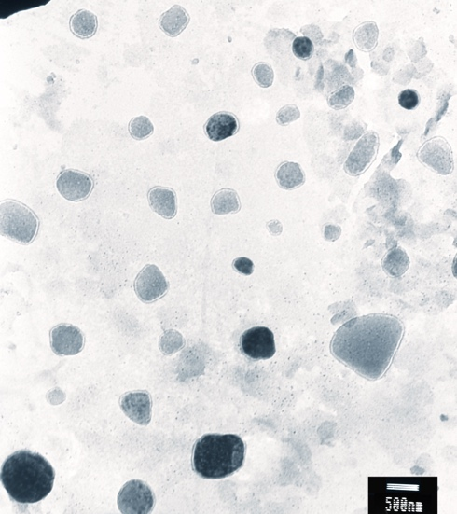 | 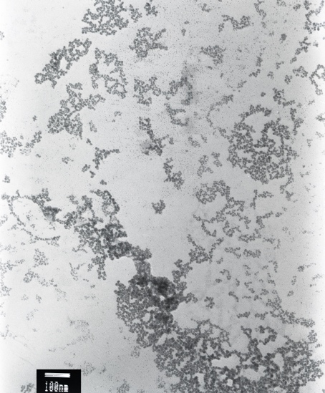
a | b
Figure 1: Microphotographs of particles of PbO, coarse fraction (a), aggregates (b).

Figure 2: Histograms of particle size distribution of PbO, fine fraction (a), coarse fraction (b).

area equal to the effective area of the particle. According to estimates (based on microphotographs), the fraction of coarse fraction is 10^{–4} – 10^{–5}.
The scattering matrices were measured by laser polarimeter, where a single-mode He–Ne laser with a wavelength of 0.63 µm and a power of 7 mW was used as a radiation source. The measurements were carried out in the scattering angle range of 10°–155°.

- Results

The experimental dependences of the matrix elements on the scattering angle for the lead oxide suspension are shown in Figure 3. In it f_{ij} are the matrix elements F_{ij} normalized on F₁₁ (f_{ij} = F_{ij}/F₁₁). Using the model of axially symmetric scatterers, the experimental data were approximated, in which the matrix elements F_{ij} were represented as the sum of the contributions of particles of different types to the resulting scattering matrix:
(1)
where θ_{k} is the scattering angle, α_{p} is the contribution of the corresponding type of particles to the scattering matrix, – the scattering cross section, and are the matrix elements of the p-th kind of particles. In the approximation, the contributions α_{i} of particles of different sorts were determined, which ensure a minimum of the sum of the squared deviations of the theoretical values of all matrix elements from the experimental (Φ₁).

For the 16 sets of four ε values considered, the smallest values of the sum of the squares of the deviations were obtained during simulating the particles of the medium by oblate spheroids with a set of values ε = 3,5,7,9. The calculated dependences of the matrix elements on the scattering angle corresponding to this case are shown in Figure 3 (dashed lines). The differences between the calculated values of f_{ij}(θ) and the experimental values can be explained by the presence of aggregates of small particles of suspended matter.
To account for the presence of aggregates, the number of particle sorts considered in solving of the approximation problem was increased to 56, by adding aggregates. It was assumed that each aggregate consists of identical monomers – oblate spheroids with ε = 5 and size (radius of a sphere of equivalent volume) a = 3 nm, and their morphology can be described by the expressions:
(2)
where D_{f} is the fractal dimension, k₀ is the prefactor, R_{g} is the radius of the gyration, x_{i} is the distance from the i-th particle of the aggregate to its center of mass. It was assumed that the suspension contains aggregates that differ in the number of monomers and in the radius of the gyration. The prefactor value was considered equal to 1.2, and the fractal dimension varied in the interval 1.8–2.5.

Table 1: Geometric and thermophysical parameters of the elements of the construction of a radioisotope thermoelectric power source.

Substrate characteristics
Length × width × height, cm × cm × cm |  | 1 × 1 × 0.05
Hole diameter, cm |  | 0.6
Thermal conductivity (Si), W/(mK) |  | 148
Characteristics of the thermal insulation layer
Length × width × height, cm × cm × cm |  | 1 × 1 × 0.002
Thermal conductivity (PVdF), W/(m · K) |  | 0.2
Characteristics of thermoelectric tracks
Width, μm |  | 100 ÷ 500
Height, μm |  | 10 ÷ 100 (10)
Thermal conductivity (Au), W/(mK) |  | 204
Thermal conductivity (Pt), W/(mK) |  | 72
Characteristics of the radioisotope source
Radius, μm | 500
Height, μm | 10
Материал | ThO₂(Thoriumdioxide-228)
Specific power, W/cm³ | 221.7
Power, mV | 17.8
Thermal conductivity, W/(mK) | 9.7

- Discussion
Values of the contributions of particles of different kinds α_{i}, providing the smallest value of Φ₁ are shown in Figure 4 in the logarithmic (a) and linear (b) scale. Since according to the data of [7], the particle size distribution is more accurately reconstructed by minimizing the sum of the squared deviations of the diagonal elements of the matrix (Φ₂), then the same figure shows the contribution values for this case. On the vertical axis in Figure 4 shows the relative fraction of particles of a representative set with dimensions lying in the interval r_{i} – r_{i} + Δr_{i}. For aggregates, this is their relative share, and for spheroids, the sum of the contributions (α_{p}) of particles with different values of ε for each size range. For aggregates, the values of R_{v} are taken as their size. The size distribution obtained by minimizing the function Φ₂ more accurately reflects the actual, since it has a maximum in the region of the smallest particle sizes. For the retrieved distribution, the fraction of coarse fraction is 10^{–4} – 10^{–5}. It should be noted that in the distributions obtained there is an extremum in the range of 200–400 nm corresponding to the maximum in the distribution of coarse fraction particles (Figure 2(b)), and an extremum in the range of 30–60 nm corresponding to the maximum in the distribution of aggregates.

- Conclusion
For a dispersed medium containing plate-like particles and their aggregates of monomers with dimensions much smaller than the radiation wavelength, despite the large difference (nine orders of magnitude) of scattering cross sections of coarse fraction particles and monomers forming aggregates, the presence of aggregates affects its scattering properties.
The use of a model of axially symmetric scatterers allows one to simulate with good accuracy the scattering properties of such a disperse medium.
Minimizing the sum of the squares of the deviations of the diagonal matrix elements measured and calculated in the framework of the spheroidal scatterers model allows us to retrieve the size distributions as for aggregates at the values of the parameter 2πR_{v}/λ > 0.1, and for coarse fraction particles.

Funding
This work was supported by Competitiveness Growth Program of the Federal Autonomous Educational Institution of Higher Professional Education National Research Nuclear University MEPhI (Moscow Engineering Physics Institute) under Grant No. [R07GM589654].

Acknowledgement
The authors would like to thank their colleague for their contribution and support to the research. They are also thankful to all the reviewers who gave their valuable inputs to the manuscript and helped in completing the paper.

Conflict of Interest

The authors have no conflict of interest to declare.

References

- Xu, R. (2002). Particle Characterization: Light Scattering Methods. New York, NY: Kluwer Academic Publishers.
Book format
- Wu, Y., Cheng, T., Zheng, L., et al. (2016). Effect of morphology on the optical properties of soot aggregated with spheroidal monomers. Journal of Quantitative Spectroscopy and Radiative Transfer, vol. 168, pp. 158–169.
Journal article format
- Mulvany, N. C. (1993). Indexing, providing access to information—Looking back, looking ahead, in Proceedings of the 25th Annual Meeting of the American Society of Indexers. Port Aransas, TX: American Society of Indexers.
Conference proceedings
- National Institute for Occupational Safety and Health (NIOSH). (February 2012). How to Prevent Musculoskeletal Disorders (Report No. 2012-120, p. 2). Department of Health and Human Services.
Reports/Working Papers/White papers
- Choi, M. (2008). Contesting Imaginaires in Death Rituals during the Northern Song Dynasty. PhD dissertation/master’s thesis, University of Chicago.
Thesis/Dissertation
- Royko, M. (1992). Next time, Dan, take aim at Arnold, Chicago Tribune, September 23.
Newspaper article

